PEANUTS AND POPCORN

This pattern will work well for Head Start. The children are birth to five.
It is so fast and easy, I cut it and made it while eating peanuts.
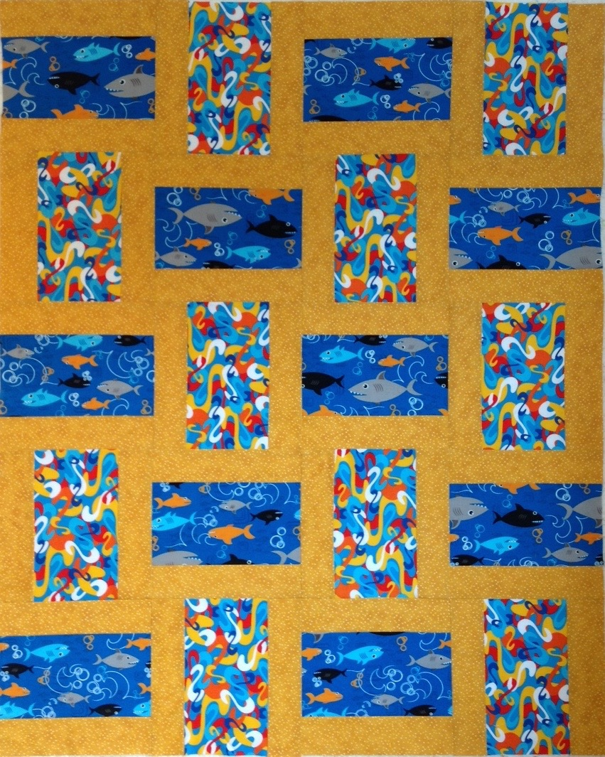
It needed a long block to show off the sharks! Carol for Community Quilts

Finished size: 36” x 45”
Finished block: 9”
Number of blocks 20

Fabric:
1/2 yard block A
1/2 yard block B
(More fabric needed for fussy cutting)

3/4 yard Sashing
1/2 yard Binding
1 1/2 yards Back

Cut 3 5 1/2” strips x WoF of block A
Subcut into ten 9 1/2” x 5 1/2”
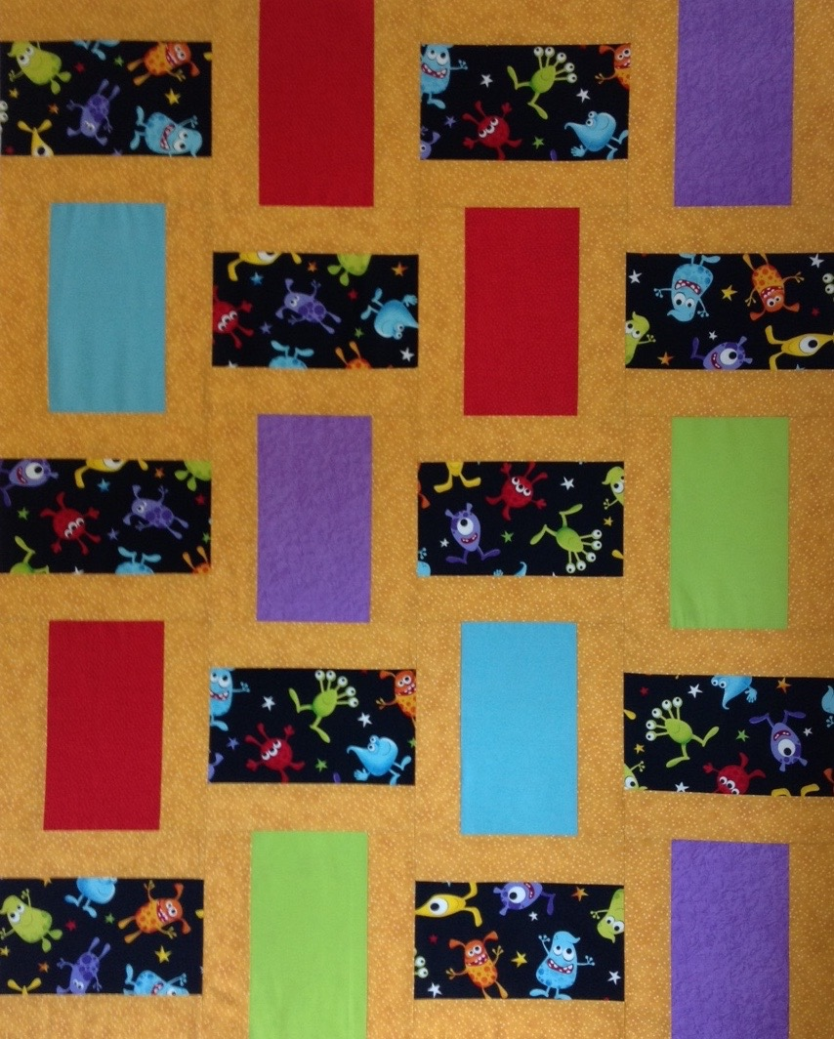
Repeat for block B

Cut 10 2 1/2” strips WoF of sashing
Sub cut into 40 9 1/2” strips

Sew a sashing strip to each long
side of the twenty rectangles.
Press toward the sash or
press seams open.

Lay out, reversing direction of the
blocks as shown.
Sew four across and five down.

This pattern will lend itself to anything
from 20 different blocks to 20 the same.
Use your imagination and your scraps!

